First get some webspace on www.000webhost.com, register a website name preferably Half(something of your choice), then we have to make a folder of your choice

For reasons I cannot remember my main site was four-faces-news.

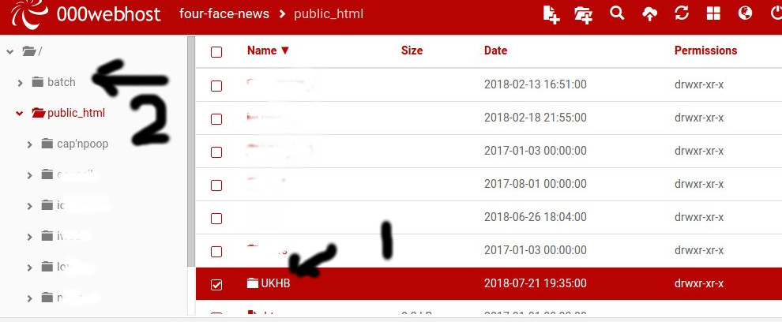

Go into your shiny new folder (I called mine UKHB) and go get this lot goes in the public html folder
https://drive.google.com/open?id=1_sRy0XdUO81zcmNOLxh-yH1kKs5X6Jqz, and put them in the folder you just made.
Edit--------------------------------
Also in your folder you need a files folder, with a subfolder in it called ideas
Edit--------------------------------
The more eagle-eyed might have noticed no 2 a thing called batch folder, which is outside the public html folder. This is to make it less easy to hack (a bit).

To make this folder go click here on whatever you called your website.
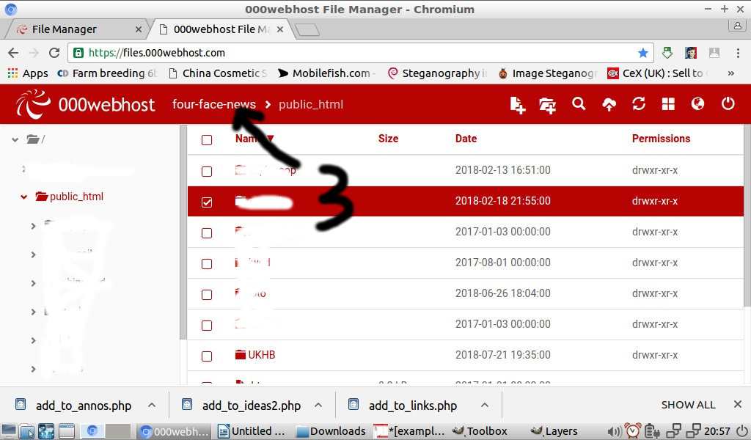

Which takes us one level up, out of the public_html folder.
Which leads us to

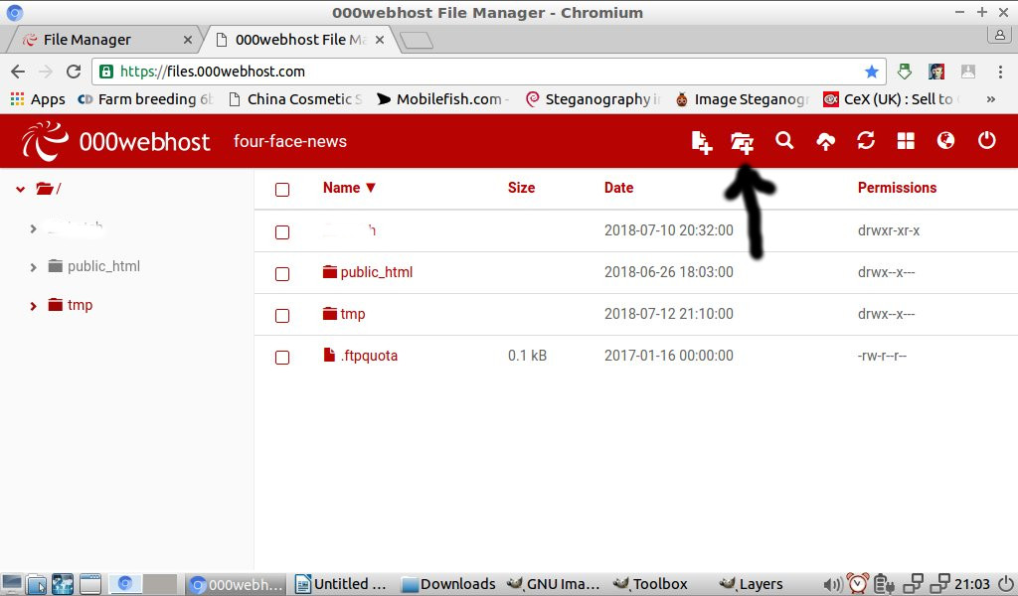
Go click on the “make a new folder” icon

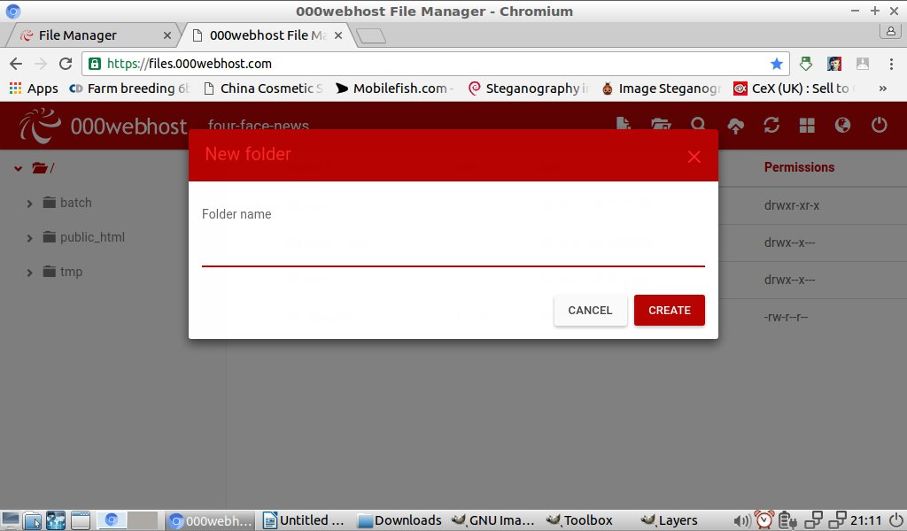
Give it the name of batch then click Create. You now have a batch folder, so open it , dump this lot goes in the batch folder
https://drive.google.com/open?id=1wFNSRIhzIJ2yBWoicyIeMAKGwXCsMg9J
Game over, go try it, there's one id already set up ,user name Archimedes , password 2good2

so try the site and make sure it works-ish.

